7 Wall Collision

The Controller Object
In order to have our little character crash into a wall and actually have that wall push back, or prevent the little guy from going through it, we are going to have to create this this controller object. The controller object is a very important element in the game, even though it is more of a ghost, which means for the most part, it is invisible.

Main purposes
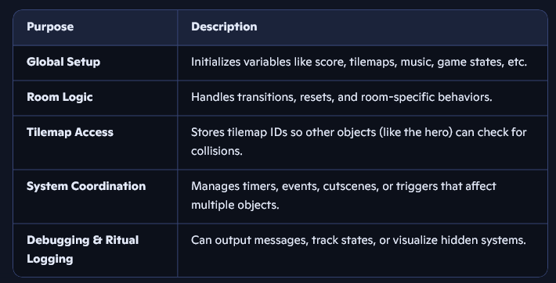
Without a controller the tilemap ID is not stored, and we need to store it so that our hero can check for collision with the wall, and other things. When you have a controller, it controls things, and when it says “Thou shall not go through them thar walls” well, you are not going to be going through any walls.

Create the Controller
if you are in the room tab, you want to go back to the Workspace 1 tab, to find the Asset Browser again.
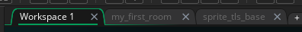
Now go to Objects in the Asset Browser.
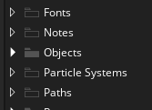
Right click on the object’s folder and then go to Create -Object
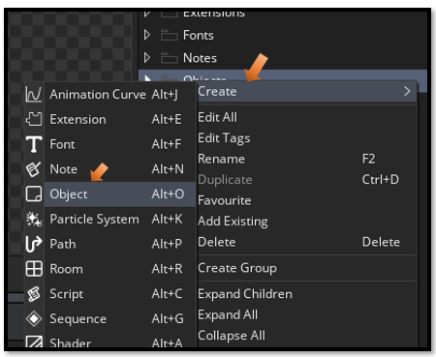
You can name it obj_controller, it will be invisible in the room, so no sprite is needed for it.
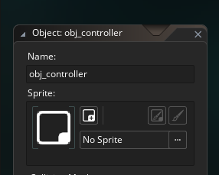

Controller Create Event
Click on the obj_controller in the Asset Browser to come into its code. Add a Create event, and put this code into the controllers create event.
global.tilemap_wall = layer_tilemap_get_id("Wall_Tiles");

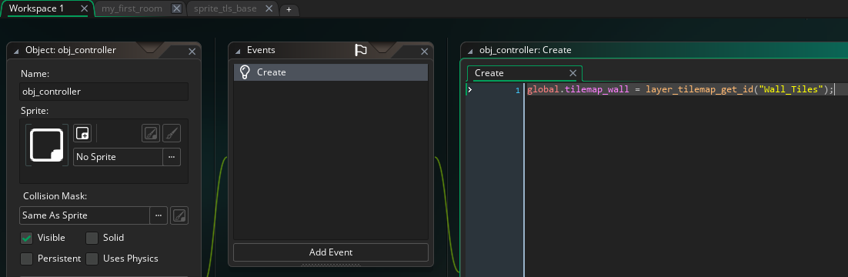

The object_hero step event, with collision
Now double click on the object_hero
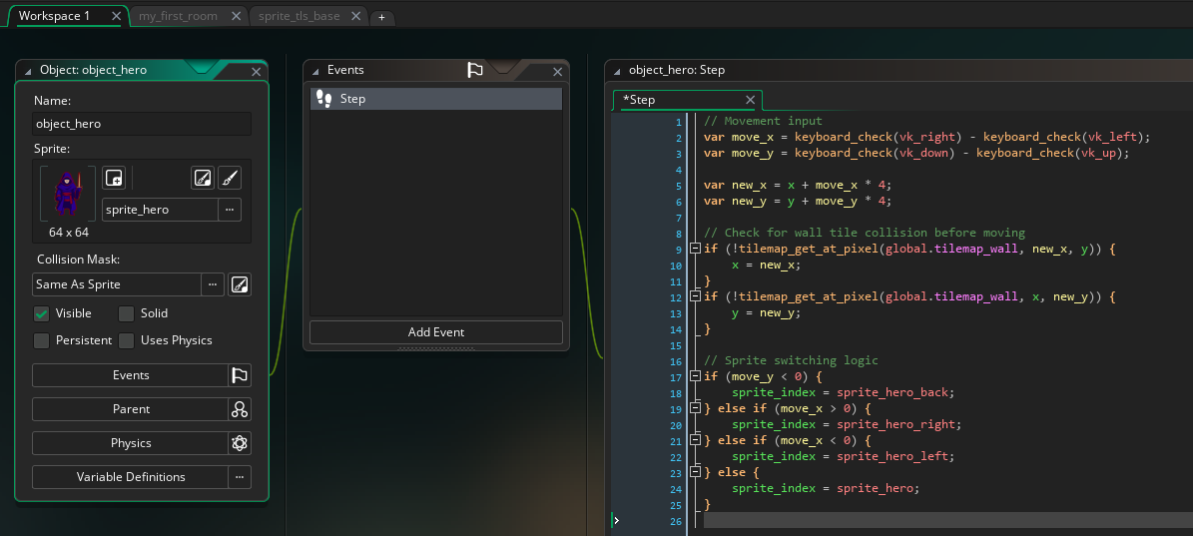

// Movement input
var move_x = keyboard_check(vk_right) - keyboard_check(vk_left);
var move_y = keyboard_check(vk_down) - keyboard_check(vk_up);

var spd = 4;
var dx = move_x * spd;
var dy = move_y * spd;

// First move on X
if (dx != 0) {
var nx_left = bbox_left + dx;
var nx_right = bbox_right + dx;
var ny_top = bbox_top;
var ny_bottom = bbox_bottom;

var hit_x =
wall_is_solid(nx_left, ny_top) ||
wall_is_solid(nx_left, ny_bottom) ||
wall_is_solid(nx_right, ny_top) ||
wall_is_solid(nx_right, ny_bottom);

if (!hit_x) x += dx;
}

// Then move on Y
if (dy != 0) {
var ny_top = bbox_top + dy;
var ny_bottom = bbox_bottom + dy;
var nx_left = bbox_left;
var nx_right = bbox_right;

var hit_y =
wall_is_solid(nx_left, ny_top) ||
wall_is_solid(nx_right, ny_top) ||
wall_is_solid(nx_left, ny_bottom) ||
wall_is_solid(nx_right, ny_bottom);

if (!hit_y) y += dy;
}

// Sprite switching
if (move_y < 0) sprite_index = sprite_hero_back;
else if (move_x > 0) sprite_index = sprite_hero_right;
else if (move_x < 0) sprite_index = sprite_hero_left;
else sprite_index = sprite_hero;

// Sprite switching logic
if (move_y < 0) {
sprite_index = sprite_hero_back;
} else if (move_x > 0) {
sprite_index = sprite_hero_right;
} else if (move_x < 0) {
sprite_index = sprite_hero_left;
} else {
sprite_index = sprite_hero;
}

A script Asset
Next we are going to create a script asset. It is not a sprite, nor an object. It is a script, and to create a script, we need to right click on this Script folder in the Asset browser.
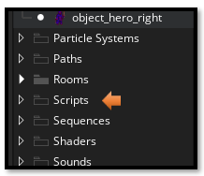
Name it: scr_collision_helpers,
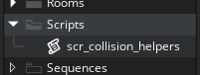
Put this code into the script.
function wall_is_solid(px, py) {
var rx = px - global.wall_layer_x;
var ry = py - global.wall_layer_y;
return tilemap_get_at_pixel(global.tilemap_wall, rx, ry) != 0;
}

Editing the collision Mask
When I tested to have my hero run up beside the right wall, I found that he was blocked, as if there was a wall in front of him. I was on the floor and yet when I hit the up arrow, my hero was blocked. That is because the collision on the mask of the hero is too far out to the right, and it needs to be editing. This seemed to only effect the hero when facing backwards.
Inset the Collision Mask
• Open your hero sprite in the Sprite Editor.
• Go to the Collision Mask tab.

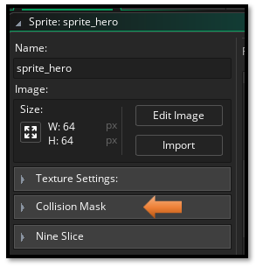
- Go to Manual here
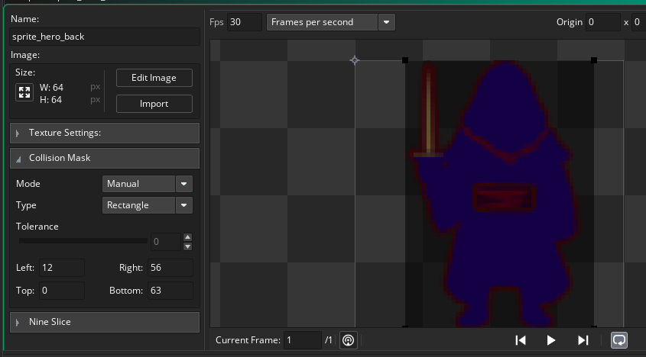

• Shrink the mask by 1–2 pixels on the right side.
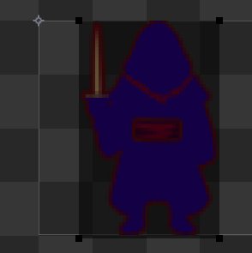
• This prevents the corner from “touching” the wall tile when you’re flush against it.
This keeps the checks inside the hero’s mask, avoiding false positives at the wall edge

